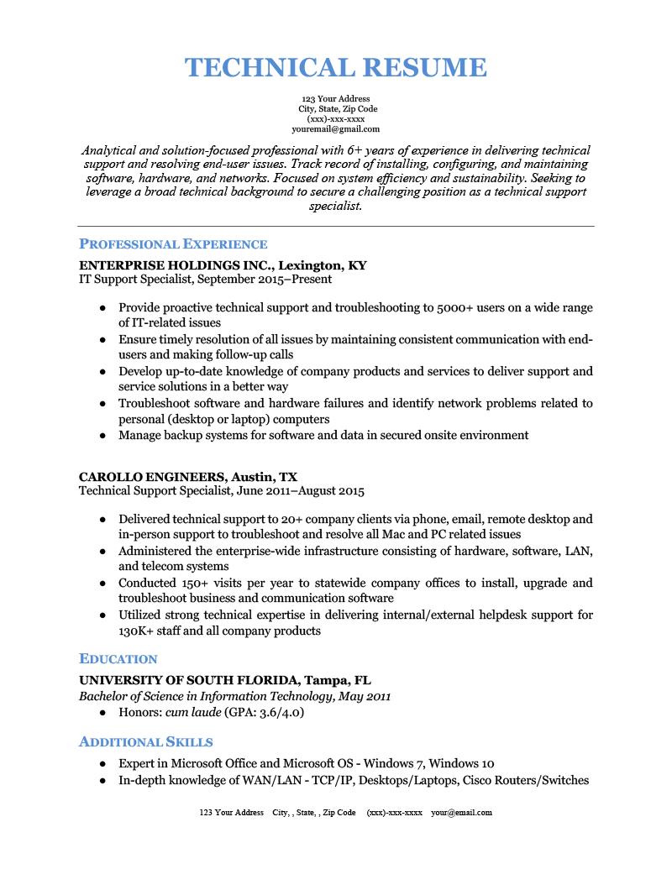
TECHNICAL RESUME
123 Your Address City, State, Zip Code (xxx)-xxx-xxxx youremail@gmail.com
Analytical and solution-focused professional with 6+ years of experience in delivering technical support and resolving end-user issues. Track record of installing, configuring, and maintaining software, hardware, and networks. Focused on system efficiency and sustainability. Seeking to leverage a broad technical background to secure a challenging position as a technical support specialist.
PROFESSIONAL EXPERIENCE
ENTERPRISE HOLDINGS INC., Lexington, KY IT Support Specialist, September 2015-Present
• Provide proactive technical support and troubleshooting to 5000+ users on a wide range of IT-related issues
• Ensure timely resolution of all issues by maintaining consistent communication with end- users and making follow-up calls
• Develop up-to-date knowledge of company products and services to deliver support and service solutions in a better way
• Troubleshoot software and hardware failures and identify network problems related to personal (desktop or laptop) computers
• Manage backup systems for software and data in secured onsite environment
CAROLLO ENGINEERS, Austin, TX
Technical Support Specialist, June 2011-August 2015
• Delivered technical support to 20+ company clients via phone, email, remote desktop and in-person support to troubleshoot and resolve all Mac and PC related issues
• Administered the enterprise-wide infrastructure consisting of hardware, software, LAN, and telecom systems
• Conducted 150+ visits per year to statewide company offices to install, upgrade and troubleshoot business and communication software
• Utilized strong technical expertise in delivering internal/external helpdesk support for 130K+ staff and all company products
EDUCATION
UNIVERSITY OF SOUTH FLORIDA, Tampa, FL Bachelor of Science in Information Technology, May 2011
⚫ Honors: cum laude (GPA: 3.6/4.0)
ADDITIONAL SKILLS
• Expert in Microsoft Office and Microsoft OS - Windows 7, Windows 10
• In-depth knowledge of WAN/LAN - TCP/IP, Desktops/Laptops, Cisco Routers/Switches
123 Your Address City,, State, Zip Code (XXX)-XXX-XXXX your@email.com

